1. **What is Messaging?**
2. The process of **exchanging** **business data/info** across applications or across components within the same app.
3. **The Key Components of Messaging System are:**
   1. **Sender**: The app which sends msgs.
   2. **Receiver**: The app which receives the msgs.
   3. **Message**: Which has the business Data/Info.
      1. A **message** may container some **networking/routing headers**.
   4. **Messaging Server:**
      1. Also known as **MOM** (**M**iddle **O**riented **M**iddleware) This is where Messaging app is deployed.
      2. **Its responsibilities:**
         1. To take the msgs from the send and ensure to deliver to the receiver.
         2. Along, it also provides other services or advantages such as
            1. Fault-Tolerance.
            2. Load Balancing.
            3. Scalability.
            4. Transaction Management.
            5. and many more that we will learn in this course.
      3. **Som popular MOMs are**:
         1. ActiveMQ.
         2. SonicMQ.
         3. WebSphere MQ from IBM.
         4. TIBCO MQ.
         5. and many more.
4. 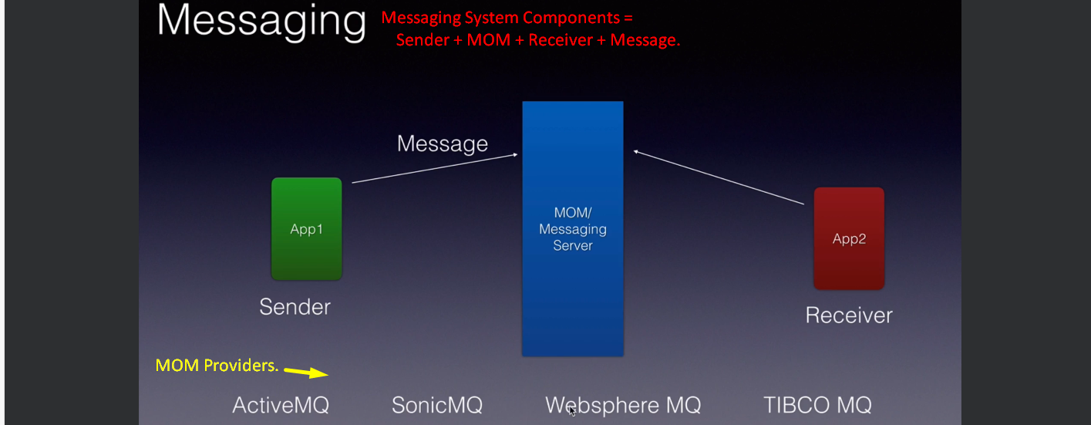
5. **Let’s try to understand Messaging System**.
6. Suppose we are going to build a **Bank Cheque Processing App**.
7. We can split it into two components.
   1. **Bank Teller**:
   2. **Check Processor**:
8. **Bank Teller:**
   1. Will be used by the Bank Employee to feed the cheque taken from a customer.
   2. When this cheque is fed into the Bank Teller App, this will send as a message to the Messaging Server (MOM).
9. **cheque** **Processor:**
   1. Through the Messaging Server (MOM), the Check Processor App will receive the msg and process it.
10. **MOM (Message-Oriented Middleware) = Messaging Server**:
    1. Here Messaging Server is completely decoupling the two app (Bank Teller & Check Processor).
    2. These two apps need to know about each other anything.
    3. If tomorrow, we want to replace Cheque Processor with some other App, we can do it without affecting the other side flow.  
       There are several other advantages which we will learn in this course.

